PROJECT REPORT
ON
“From BI to Big Data: Explain, Design & Defend”

Subject Name: Big Data Analytics
Subject Code: BAD601
Submitted By: Submitted To:
Aishwarya B Katerpatte-1AY23CD006 Ms.Surbhi

Table of Contents

SI.No. | Content | Page No.
1. | About the project | 1-2
2. | About the tools and technologies used | 3-6
3. | Detailed description of my contribution | 7-8
4. | Implementation | 9-11
5. | Results | 11-16
6. | Conclusion | 17

1. Introduction:
In the present digital era, data has become one of the most valuable resources for organizations across the world. Every activity performed online — such as searching for products, making payments, posting reviews, browsing websites, or using mobile applications — generates data. With the rapid growth of e-commerce platforms, social media, smartphones, and cloud computing, the volume of data being generated has increased exponentially. Managing and extracting useful insights from such massive datasets has become a major challenge for businesses.Traditional data management systems were designed to handle structured data stored in relational databases. These systems work efficiently when the data is limited in size, organized in tables, and processed in batches. However, modern business environments require real-time decision-making and the ability to process diverse forms of data such as text, images, videos, click logs, and streaming data. This is where the concept of Big Data becomes significant.
Big Data refers to extremely large and complex datasets that cannot be efficiently processed using conventional database systems. It is commonly characterized by the five important dimensions known as the 5 V’s — Volume, Velocity, Variety, Veracity, and Value. Volume represents the enormous amount of data generated daily. Velocity indicates the speed at which data is produced and needs to be processed. Variety refers to different forms of data including structured, semi-structured, and unstructured formats. Veracity highlights the reliability and accuracy of data, while Value emphasizes the importance of converting raw data into meaningful business insights.E-commerce platforms such as Amazon generate massive data from customer transactions, browsing history, product reviews, inventory systems, payment gateways, and logistics operations. Handling such data using traditional Business Intelligence (BI) tools alone is not sufficient due to scalability and real-time processing limitations. To overcome these challenges, organizations adopt Big Data technologies such as Hadoop, Spark, NoSQL databases, and distributed storage systems.
This project focuses on understanding the fundamentals of Big Data and analyzing its practical application in an Amazon-like e-commerce environment. It compares Traditional Data Warehouse architecture with Hadoop-based Big Data architecture.
1.1 Project Objectives:
The major objectives of this project are:
- To understand the characteristics of Big Data (5 V’s).
- To analyze the drawbacks of traditional BI systems.
- To design and compare Traditional Data Warehouse and Hadoop-based architectures.
- To identify appropriate analytics techniques for business questions.
- To understand the business value generated through Big Data technologies.
The real-world application that I have chosen is Amazon-An E-commerce app.Amazon collects different forms of data such as order details, payment records, product reviews, click logs, and browsing behavior. These data types include structured, semi-structured, and unstructured formats.Traditional databases are mainly designed to manage structured tables. However, Amazon’s data is not limited to structured formats. It includes text reviews, images, logs, and real-time streaming data. Because of this diversity and scale, advanced Big Data technologies are required.
Big Data helps Amazon improve delivery efficiency, suggest personalized products, detect fraud, and make accurate business predictions.

2. About the tools and technologies studied:
This project does not involve practical deployment of Big Data tools. Instead, it focuses on understanding and analyzing the technologies that are commonly used in large-scale data environments such as Amazon’s e-commerce platform. The following tools were studied conceptually as part of the architectural comparison and analytical mapping.
2.1 Hadoop
Hadoop was studied as a distributed framework designed for storing and processing very large datasets. It works by dividing data across multiple machines instead of relying on a single server.
Architecture of Hadoop:
Hadoop primarily consists of two core components:

1. HDFS (Hadoop Distributed File System)
HDFS is responsible for storing data in a distributed manner. Instead of storing an entire dataset on a single machine, it divides data into smaller blocks and distributes them across multiple nodes. This ensures:Fault tolerance, Data redundancy, Scalability, High availability
If one system fails, the data can still be recovered from another node.

2. MapReduce
MapReduce is a programming model used for processing large datasets in parallel. It divides the task into smaller subtasks (Map phase) and then combines the results (Reduce phase).Although MapReduce is slower compared to modern frameworks, it laid the foundation for distributed data processing.

Role in Big Data Architecture

In this project, Hadoop was studied as the backbone of distributed storage. It solves the Volume problem of Big Data by enabling horizontal scaling. Instead of upgrading one machine, more systems can be added to the cluster.

2.2 Apache Spark
Apache Spark is a fast and general-purpose data processing engine. It was developed to improve the speed and efficiency of data processing compared to Hadoop MapReduce.

Key Features of Spark
- In-memory processing
- Faster execution
- Support for batch and real-time analytics
- Machine learning capabilities
Unlike MapReduce, Spark stores intermediate results in memory, which significantly improves processing speed.
Importance in E-Commerce Systems
In an e-commerce platform, Spark can be used for:
- Recommendation systems
- Predictive analytics
- Fraud detection
- Customer behavior analysis
2.3 NoSQL Databases
Traditional relational databases use structured tables with predefined schemas. However, modern applications generate flexible and rapidly changing data formats.
NoSQL databases were introduced to handle: Semi-structured data, Unstructured data, High-velocity data, Dynamic schemas

Advantages
- High scalability
- Flexible schema
- Faster writes and reads
- Suitable for big datasets
In an Amazon-like system, NoSQL databases are useful for storing:
- Product reviews
- User session data
- JSON documents
- Clickstream data
In this project, NoSQL was evaluated as part of prescriptive analytics and large-scale storage solutions.

2.4 Business Intelligence (BI) Tools
Business Intelligence tools such as Power BI and Tableau are widely used for data visualization and reporting. They help organizations understand historical performance.

Functions of BI Tools
- Dashboard creation
- Data visualization
- Trend analysis
- KPI monitoring
BI tools mainly support Descriptive Analytics, which answers the question:
“What happened?”

Limitations of Traditional BI
- Handles mainly structured data
- Limited scalability
- Not suitable for real-time massive data streams
- Requires predefined schemas
This project compares BI tools with Big Data technologies to show how modern systems extend beyond descriptive reporting.

3. Detailed description of my contribution

3.1 Task 1 – Visual Storytelling Poster
I created a poster explaining how Big Data works in Amazon’s daily operations. The poster includes the 5 V’s of Big Data, classification of data types, and reasons why traditional BI systems are insufficient. This task helped in simplifying technical concepts into visual representation.

3.2 Task 2 – BI vs Big Data Role Play
I developed a structured dialogue between a Data Consultant and a Business Manager. The role play explains the limitations of Excel and SQL, and highlights the need for Hadoop and NoSQL in modern businesses. This task focused on conceptual clarity rather than technical implementation.

3.3 Task 3 – Architecture Design
I designed two architectures:
- Traditional Data Warehouse Architecture
- Hadoop-Based Big Data Architecture
The design includes labeled components such as data sources, storage layer, processing layer, and analytics layer. The comparison demonstrates scalability and real-time advantages of Big Data systems.
3.4 Task 4 – Analytics & Tool Mapping
I mapped business questions to different types of analytics:
- Descriptive
- Diagnostic
- Predictive
- Prescriptive
Each analytics type was associated with suitable tools conceptually.

3.5 Bonus Task
I explained Big Data creatively using an online gaming example to simplify complex ideas.

4. Implementation of code
4.1 Overview of the implementation
The implementation phase involved:
- Importing of the Amazon sales dataset into Power BI
- Performing data cleaning and validation
- Creating a DAX measure for an analytical calculations
- Designing interactive dashboard visuals
4.2 DAX Measure Implementation:
- Total Revenue = SUM('amazon_sales_data 2025'[Total Sales])
- Total Orders = COUNT('amazon_sales_data 2025'[Order ID])
- Total Quantity = SUM('amazon_sales_data 2025'[Quantity])
- Average Order Value = DIVIDE([Total Revenue],[Total Orders])
4.3 Create Dashboard Visuals
The calculated measures were mapped to Power BI as follows:
KPI cards:
- Total Revenue
- Total Orders
- Total Quantity
- Average Order Value
These provide an overall summary of the Amazon sales.

Monthly Sales Trend: This shows the sales trend over time.
Insert → Line Chart
X-Axis → Date
Y-Axis → Total Sales
Sales by Category: Shows best performing category.
Insert → Column Chart
Axis → Category
Values → Total Sales
Payment Method Analysis: Shows preferred payment mode.
Insert → Pie Chart
Legend → Payment Method
Values → Total Sales

Figure 1.1 Amazon Sales Dataset
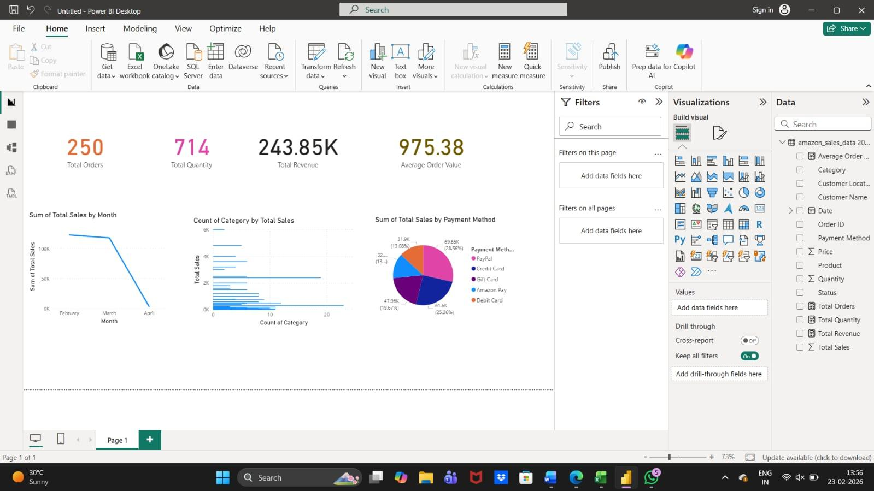
Figure 1.2 Interactive Amazon Sales Dashboard created using Power BI
Dataset used: https://www.kaggle.com/datasets/karkavelrajaj/amazon-sales-dataset
5. Results
5.1 Task 1: Big Data in Daily Life – Visual Storytelling
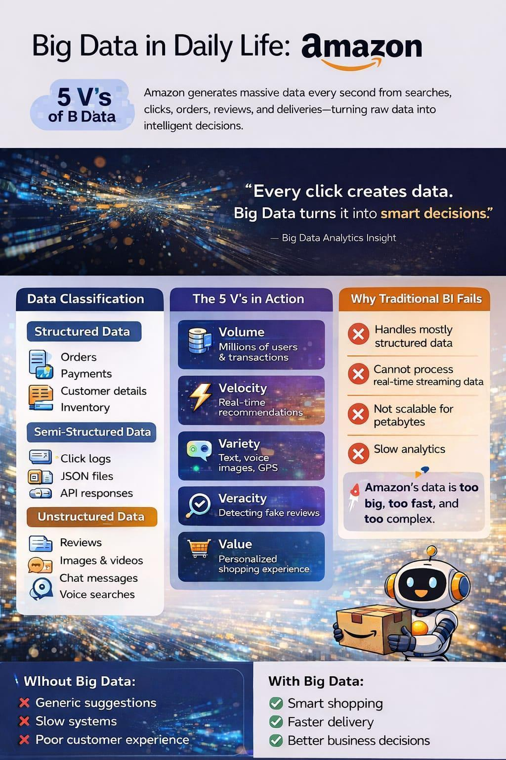

Figure 1.3 Big Data in Daily Life- Poster
This poster illustrates how Big Data functions in Amazon’s daily operations by highlighting the 5 V’s — Volume, Velocity, Variety, Veracity, and Value. It explains how Amazon gathers structured, semi-structured, and unstructured data such as orders, click logs, reviews, and images. The poster also shows why traditional BI systems are insufficient and how Big Data enables better recommendations, faster delivery, and improved customer experience.

5.2 Task 2: BI vs Big Data – Role Play
Conversation Between a Data Consultant and a Business Manager
Manager: I still believe Excel and SQL are enough for our business. Why complicate things?
Data Consultant: They’re useful, but only for small and structured data. How much data are you handling now?
Manager: It’s growing fast — sales, website traffic, customer feedback.
Data Consultant: That’s the first limitation of Traditional BI — volume. Excel and single-server databases struggle with massive data.
Manager: But SQL databases are powerful, right?
Data Consultant: Yes, but they mainly handle structured data. What about reviews, social media posts, and call recordings?
Manager: We don’t analyze those much. They’re unstructured.
Data Consultant: Exactly — that’s the second limitation: variety. Traditional systems aren’t built for diverse data formats.
Manager: But we already generate monthly reports. Isn’t that enough?
Data Consultant: Traditional BI answers “What happened?” Big Data helps answer “Why did it happen?” and “What will happen next?”
Manager: So why has Big Data become so important now?
Data Consultant: Because of digital growth — e-commerce, smartphones, IoT — data is now generated in huge amounts and at high speed.
Manager: High speed?
Data Consultant: Yes — that’s velocity. Real-time transactions and clicks require faster processing than batch reports.
Manager: Okay… so where does Hadoop come in?
Data Consultant: Hadoop was designed to store and process huge data across multiple cheap machines instead of one expensive server. It solves the volume problem using distributed storage.
Manager: And NoSQL? Is SQL outdated now?
Data Consultant: Not outdated — but limited to flexible data. NoSQL databases handle:
● JSON data
● Logs
● Social media
● Rapidly changing structures
They solve variety and velocity problems.
Manager: What are the real business benefits?
Data Consultant: Better customer targeting, accurate forecasting, personalized recommendations, fraud detection, and faster decision-making. Excel and SQL are useful — but Big Data tools give you a competitive edge.

5.3 Task 3: Architecture Design Challenge
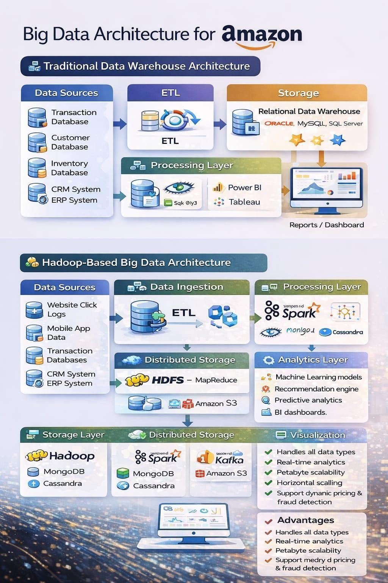
Figure 1.2 Traditional and Hadoop based Big Data Architectures
This diagram compares the Traditional Data Warehouse Architecture with the Hadoop-Based Big Data Architecture for Amazon. The traditional model uses ETL and relational databases for structured data and batch reporting, while the Hadoop-based architecture supports distributed storage, real-time processing, and advanced analytics. It highlights how Big Data systems provide scalability, handle diverse data types, and enable machine learning and predictive insights.
5.4 Task 4: Analytics & Tool Match

Business Question | Analytics Type | Tools
What happened? (How many products were sold yesterday?) | Descriptive Analytics | BI Tools (Power BI/Tableau), Hadoop
Why did it happen? (Why did sales drop in a category?) | Diagnostic Analytics | Hadoop, Spark
What will happen next? (Which products will trend next month?) | Predictive Analytics | Spark (MLib), Hadoop
What action should be taken? (Which products should be recommended or discounted? | Prescriptive Analytics | Spark + Machine Learning, NoSQL

Table 1.1 Types of Analytics
The table explains how different types of analytics support business decision-making. It links key business questions with suitable analytics methods and tools, moving from analyzing past performance to predicting future trends and recommending actions.Descriptive analytics summarizes past data, diagnostic analytics identifies causes, predictive analytics forecasts future outcomes, and prescriptive analytics suggests the best actions to achieve business goals.

Conclusion
This project examined the shift from Traditional Business Intelligence systems to modern Big Data architectures in response to the growing scale and complexity of digital data. The comparison showed that traditional data warehouses are limited when handling large, fast, and diverse datasets, whereas Big Data frameworks provide scalable storage and efficient processing.
By analyzing different analytics types and system designs, the project demonstrated how organizations convert raw data into meaningful insights and informed decisions. Overall, the study highlights the importance of adopting advanced data technologies to achieve better performance, improved customer experience, and sustainable business growth.

Github: Aishwarya-2351

